- SWAPPING WITH TEMP VARIABLE
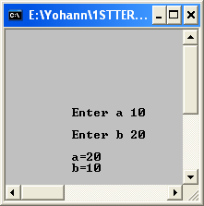
//ASS 2/1WAP to swap digits with a temporary variable
#include <iostream.h>
#include <conio.h>
main()
{
clrscr();
int a,b,c;
cout<<" \n\n\n\n\n\n\n\t Enter a ";
cin>>a;
cout<<" \n\t Enter b ";
cin>>b;
c=a;
a=b;
b=c;
cout<<"\n\t a="<<a;
cout<<"\n\t b="<<b;
getch();
}

- SWAPPING WITHOUT TEMP VARIABLE

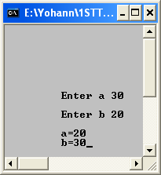
//ASS 2/2WAP to swap digits without a temporary variable
#include <iostream.h>
#include <conio.h>
main()
{
clrscr();
int a,b;
cout<<"\n\n\n\n\n\n\n\t Enter a ";
cin>>a;
cout<<"\n\t Enter b ";
cin>>b;
a=a+b;
b=a-b;
a=a-b;
cout<<"\n\t a="<<a;
cout<<"\n\t b="<<b;
getch();
}

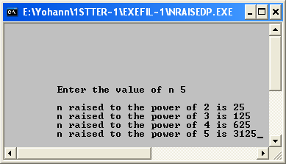
- N raised to the power of 1,2,3,4 and 5
//ASS 2/3WAP that raises number to power
#include <iostream.h>
#include <conio.h>
main()
{
clrscr();
int n;
cout<<"\n\n\n\n\n\n\n\t Enter the value of n ";
cin>>n;
cout<<"\n\t n raised to the power of 2 is "<<n*n;
cout<<"\n\t n raised to the power of 3 is "<<n*n*n;
cout<<"\n\t n raised to the power of 4 is "<<n*n*n*n;
cout<<"\n\t n raised to the power of 5 is "<<n*n*n*n*n;
getch();
}

- ALL POSSIBLE COMBOS

//ASS 2/4WAP that prints all possible combinations of digits
# include<iostream.h>
#include<conio.h>
main()
{
clrscr();
int a,b,c,d,e;
cout<<"\n\n\n\t Enter the number ";
cin>>a;
b=a/100;
c=a%10;
d=a/10;
e=d%10;
cout<<"All possible combinations are: \n";
cout<<b<<e<<c<<"\n";
cout<<b<<c<<e<<"\n";
cout<<e<<c<<b<<"\n";
cout<<e<<b<<c<<"\n";
cout<<c<<e<<b<<"\n";
cout<<c<<b<<e;
getch();
}

- SIMPLE INTEREST

//ASS 2/5WAP that prints Simple Interest
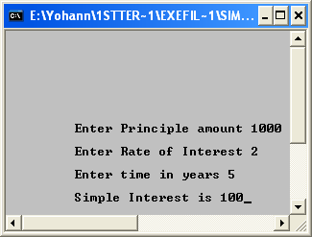
#include <iostream.h>
#include <conio.h>
main()
{
clrscr();
float si,pr,r,t;
cout<<"\n\n\n\n\n\n\n\n\t Enter Principle amount ";
cin>>pr;
cout<<"\n\t Enter Rate of Interest ";
cin>>r;
cout<<"\n\t Enter time in years ";
cin>>t;
si=(pr*r*t)/100.0;
cout<<"\n\t Simple Interest is "<<si;
getch();
}

- SUM OF DIGITS

//ASS 2/6 WAP that prints sum of digits.
#include<iostream.h>
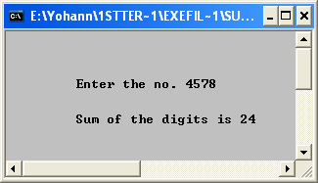
#include <conio.h>
main()
{
clrscr();
int a,b,c,d,e,f;
cout<<"\n\n\n\n\t Enter the no. ";
cin>>a;
b=a/1000;
c=a%10;
a=a/10;
d=a%10;
a=a/10;
e=a%10;
f=b+c+d+e;
cout<<"\n\n\t Sum of the digits is "<<f;
getch();
}

